Practise Questions.
Taxation of Partnerships-

Question 1- CAA -ITC Module 2019
David and Samuel practise as Quantity Surveyors in Harare. Samuel joined the practice when he qualified in July 2006. David has practised here for seven years. They submit the following profit and loss account in support of income returns for the tax year ended 31 December 2014.

Description | Amount | Description | Amount
Insurance
Loss of profit | 6 000,00 | Fees Accrued | 398 500,00
Fire | 3 600,00 | Bad debts recovered | 8 400,00
Partnership Joint Life Policy | 3 800,00 | Bank Interest | 7 500,00
Life policies of Partners |  | Debenture interest | 2 000,00
Samuel | 1 600,00 | Dividend delta corporation | 900,00
David | 1 000,00
Medical Aid Contribution
David | 5 200,00
Samuel | 3 200,00
Staff | 11 000,00
Staff salaries | 68 000,00
Annuity to widow of the deceased employee | 21 000,00
Interest on Capital
David | 4 800,00
Samuel | 4 400,00
Bad bebts | 9 700,00
trade subscriptions | 1 000,00
Legal expenses | 6 000,00
Depreciation | 86 000,00
Net Profit | - 331 300,00
David (60%) | 108 600,00
Samuel (40%) | 72 400,00
 | 181 000,00 |  | 417 300,00

Notes
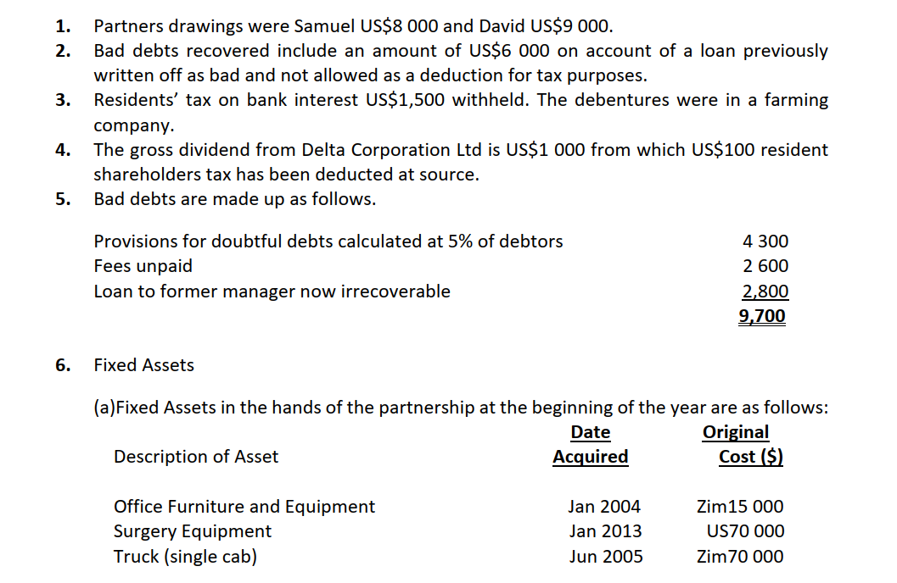
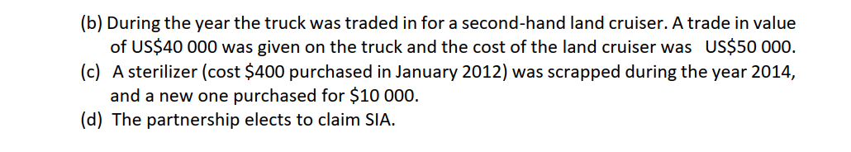
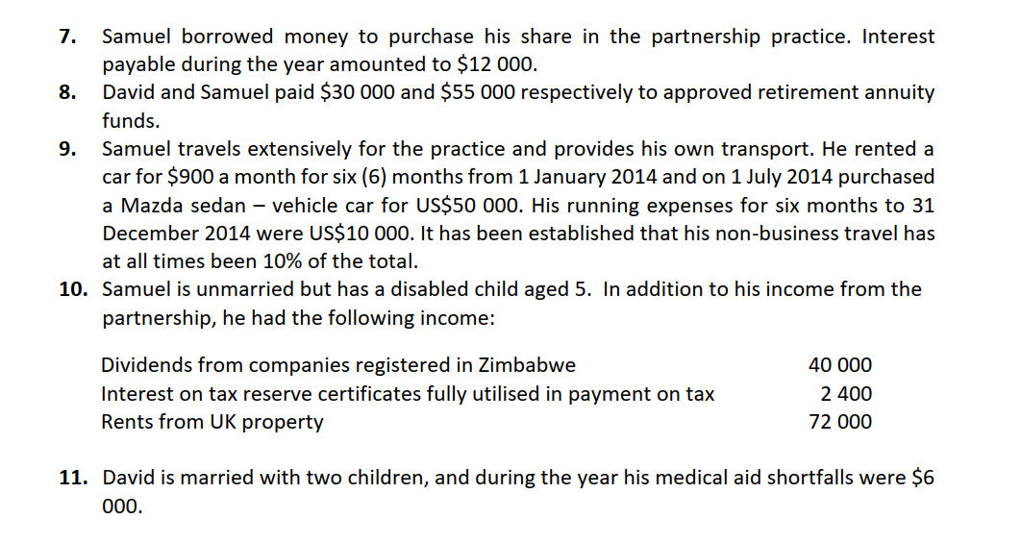
Required
Calculate the taxable income of David and Samuel for the current year of assessment
Question 2 Sabelo Nare

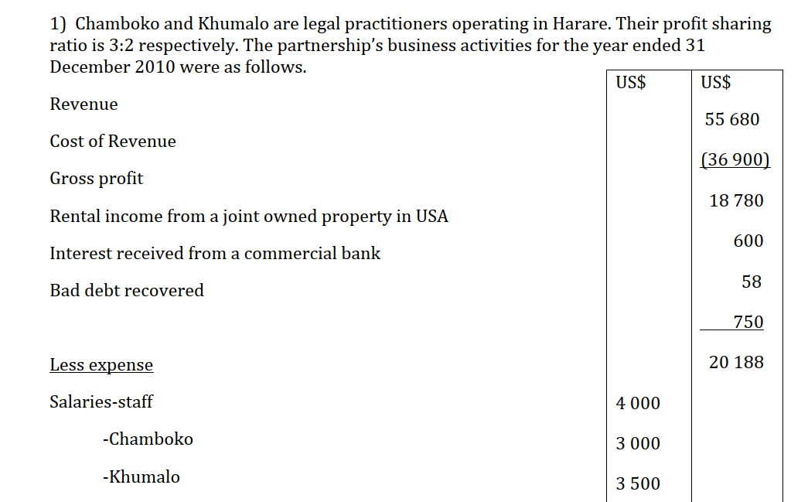
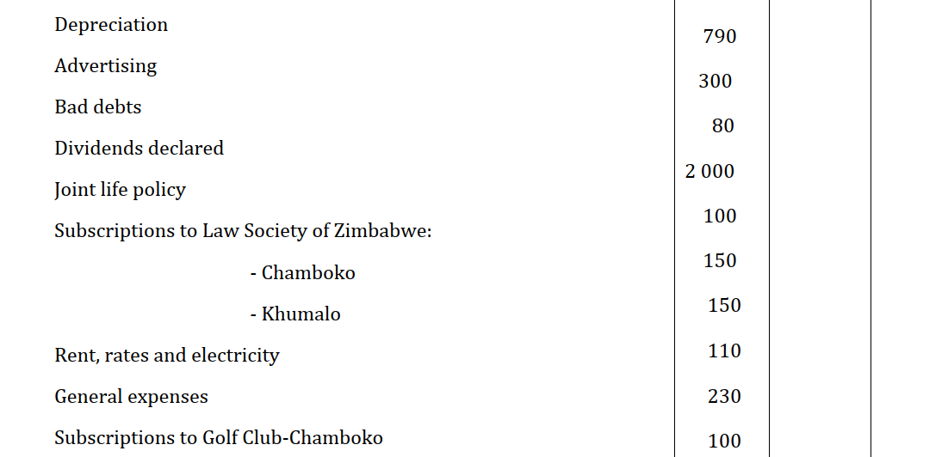
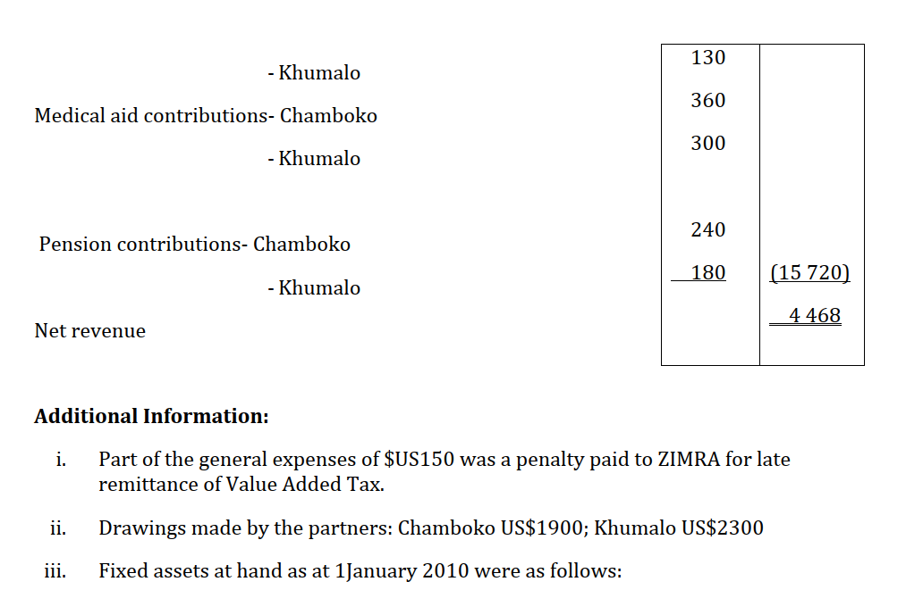
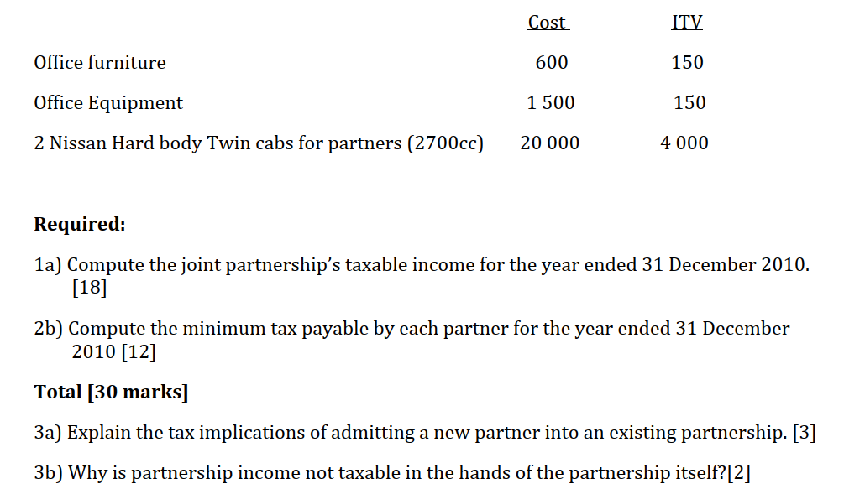

Sabelo Nare- Second Question Page 107

